**HOTEL MANAGEMENT**

**Submitted by:**

|  |  |
| --- | --- |
| Anvitha Bhaskar | 1JS20CS034 |
| Arya Vijay Pillai | 1JS20CS035 |
| Chiranthana B U | 1JS20CS053 |

**Create table commands:**

> create table booking(bid varchar(20) primary key,

-> rid varchar(20),

-> cid varchar(20),

-> bdate varchar(20),

-> checkin varchar(20),

-> checkout varchar(20));

> create table customer(cid varchar(20) primary key,

-> cname varchar(20),

-> addr varchar(20),

-> phno varchar(20),

-> id varchar(20),

-> dob varchar(20),

-> age int

-> CHECK(age>=18));

> create table employee(eid varchar(20) primary key,

-> ename varchar(20),

-> loginid varchar(20),

-> etype varchar(20));

> create table payment(pid varchar(20) NOT NULL,

-> cid varchar(20) references customer(cid) on delete cascade,

-> ptype varchar(20),

-> pdate varchar(20),

-> amount varchar(20),

-> UNIQUE(pid));

> create table room(rid varchar(20) primary key,

-> rtype varchar(20),

-> rno varchar(20),

-> cid varchar(20) references customer(cid) on delete cascade,

-> eid varchar(20) references employee(eid) on delete cascade);

**Insert table commands:**

insert into booking values('1','r4','c1','17 jan 2022','20 jan 2022','24 jan 2022');

insert into booking values('2','r3','c2','28 feb 2022','2 mar 2022','10 mar 2022');

insert into booking values('3','r4','c3','19 nov 2022','25 nov 2022','30 nov 2022');

insert into booking values('4','r5','c4','23 dec 2022','26 dec 2022','2 jan 2023');

insert into booking values('5','r1','c5','7 jun 2022','10 jun 2022','11 jun 2022');

insert into booking values('6','r2','c5','7 jun 2022','10 jun 2022','11 jun 2022');

insert into customer values('c1','theju','abc','123','adhar','17 jan 2002','22');

insert into customer values('c2','charu','def','456','pan','24 feb 2002','22');

insert into customer values('c3','chirag','ghi','789','adhar','17 nov 1995','25');

insert into customer values('c4','aditya','jkl','100','dl','19 dec 1980','40');

insert into customer values('c5','dhanush','mno','999','adhar','11 jun 1975','50');

insert into employee values('e1','josh','xxx','chef');

insert into employee values('e2','arya','yyy','security');

insert into employee values('e3','ross','zzz','roomservice');

insert into employee values('e4','tushar','xyz','manager');

insert into employee values('e5','anne','uvw','receptionist');

insert into payment values('p1','c2','online','28 feb 2022','20000');

insert into payment values('p2','c3','cash','19 nov 2022','10000');

insert into payment values('p3','c4','card','23 dec 2022','15000');

insert into payment values('p4','c5','upi','7 jun 2022','7000');

insert into payment values('p5','c5','upi','7 jun 2022','17000');

insert into payment values('p6','c1','cash','24 jan 2022','');

insert into room values('r1','1br','101','c5','e3');

insert into room values('r2','2br','202','c5','e3');

insert into room values('r3','suite','302','c2','e3');

insert into room values('r4','dorm','303','c3','e3');

insert into room values('r5','villa','405','c4','e1');

insert into room values('r6','3br','305','c1','e3');

**Tables:**

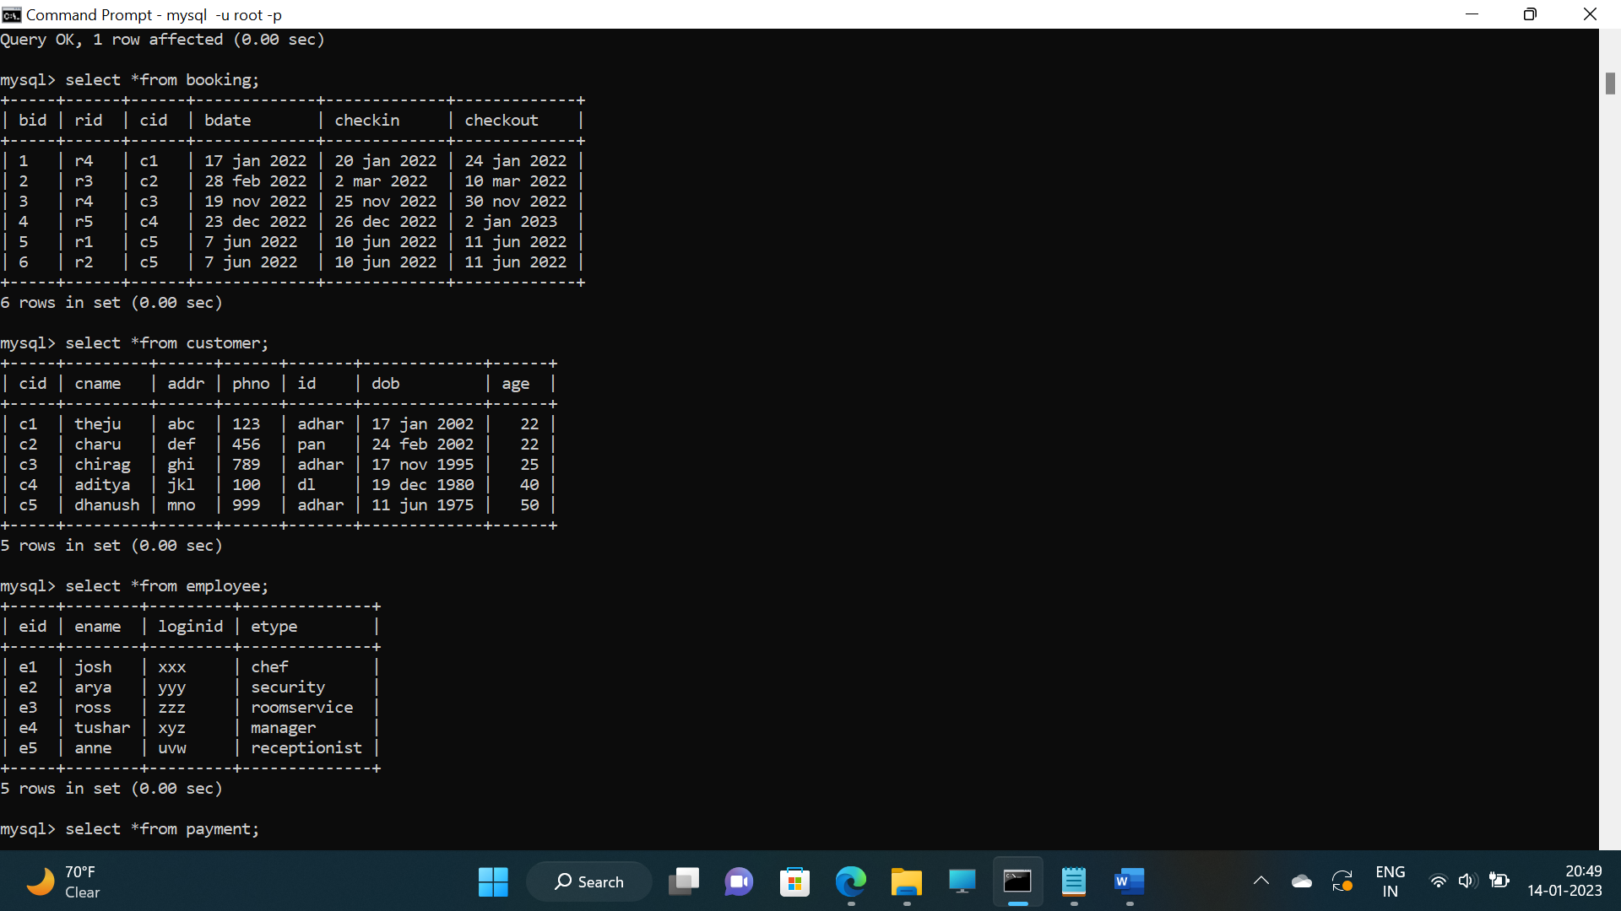





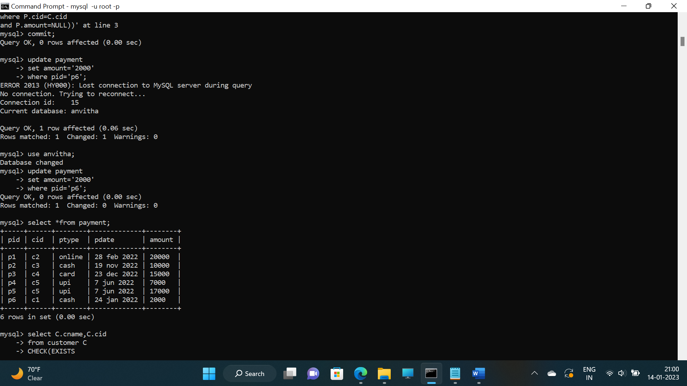

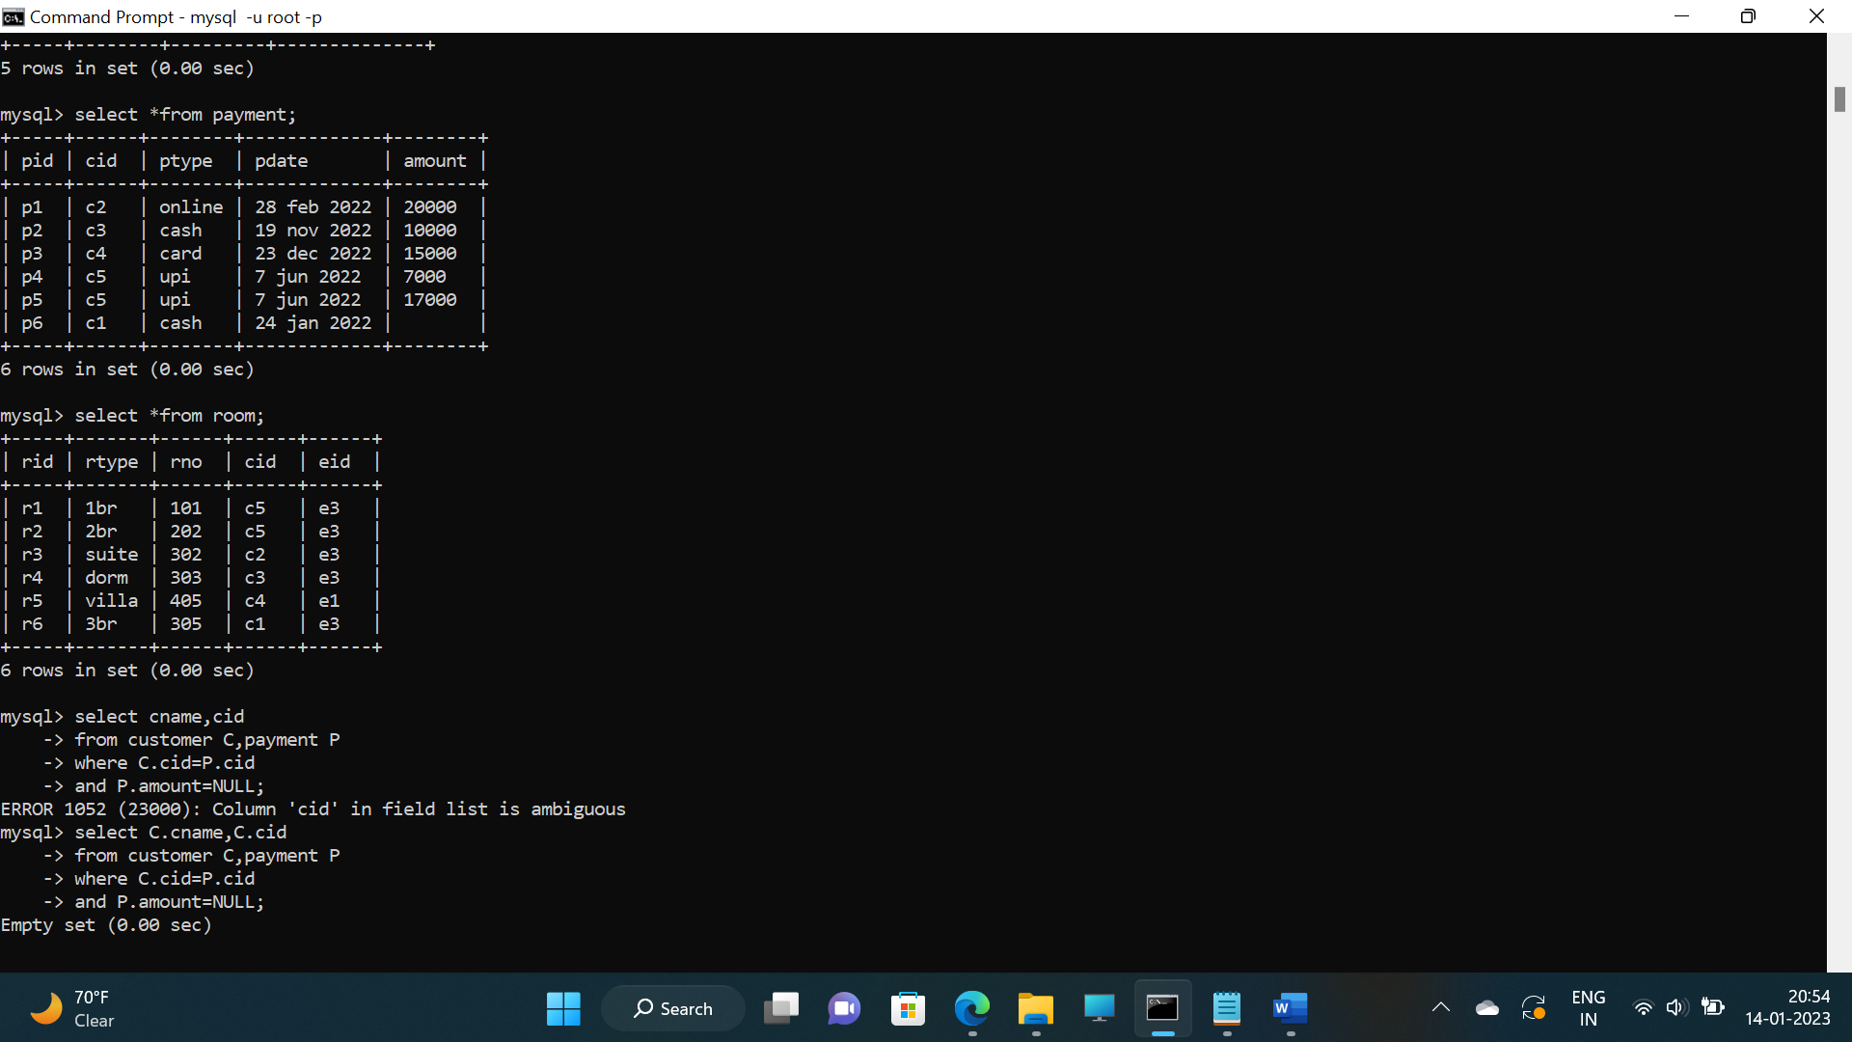

**Queries:**

1. List the customers who have amount greater than 10000.

>select C.cname, C.cid

from customer C, payment P

where P.cid=C.cid

and P.amount>10000;

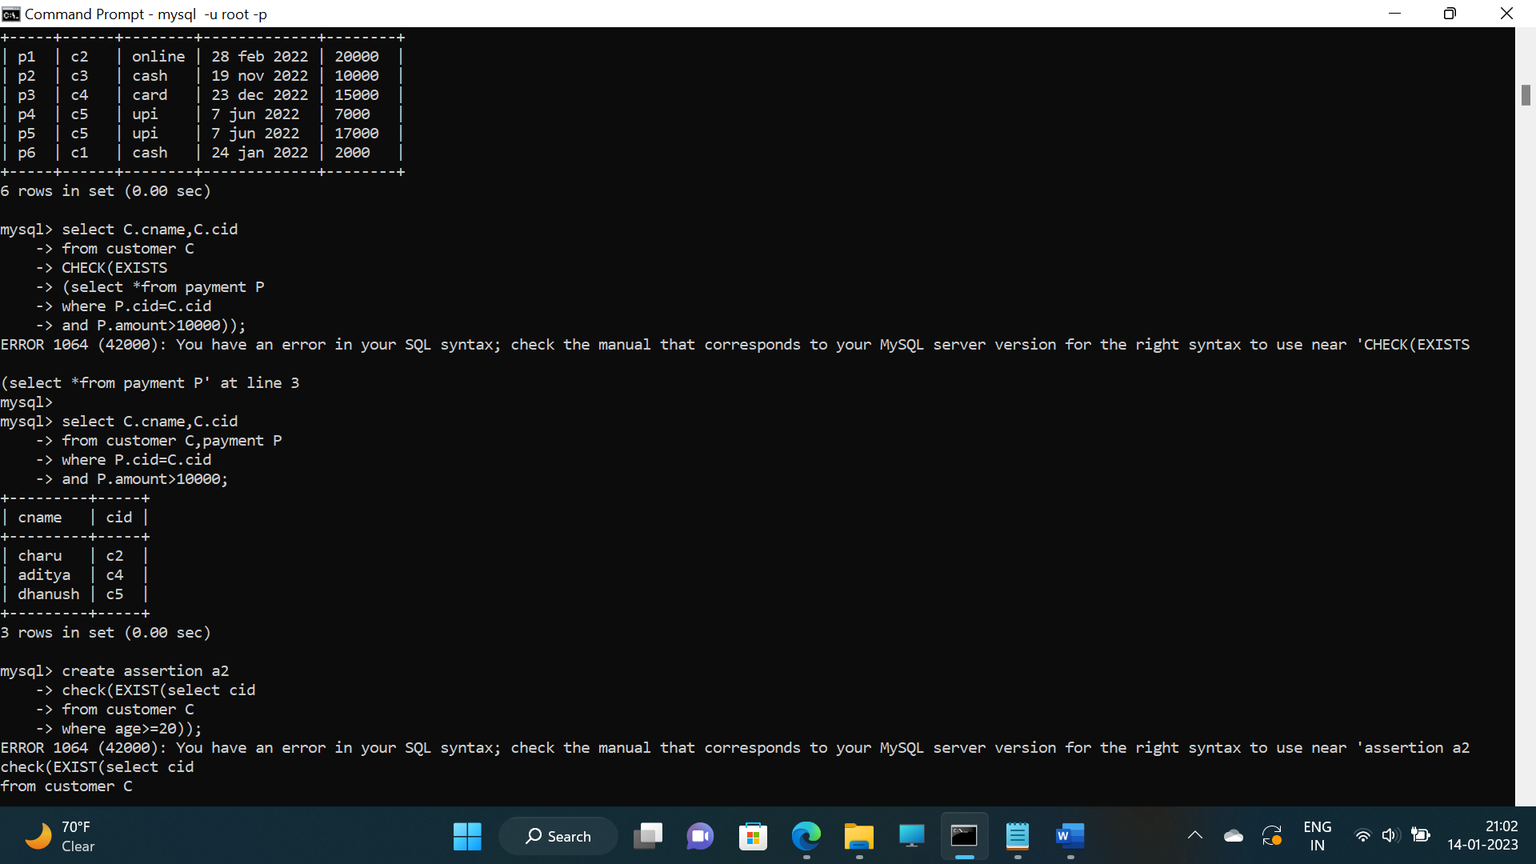

1. List the customer name who have booked more than 1 room.

>select cname,cid

from customer C

where 1<(select count(*)

from room R

where C.cid=R.cid);

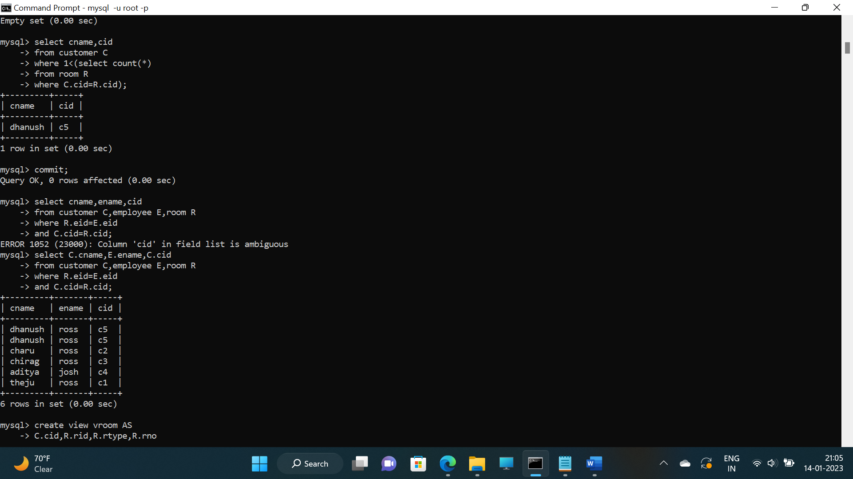

1. List the customers for a particular employee.

>select C.cname, E.ename, C.cid

from customer C, employee E, room R

where R.eid=E.eid

and C.cid=R.cid;



1. Create view of all the rooms and number of customers in the room.

>create view vroom AS

select C.cid,R.rid,R.rtype,R.rno

from customer C, room R

where R.cid=C.cid;

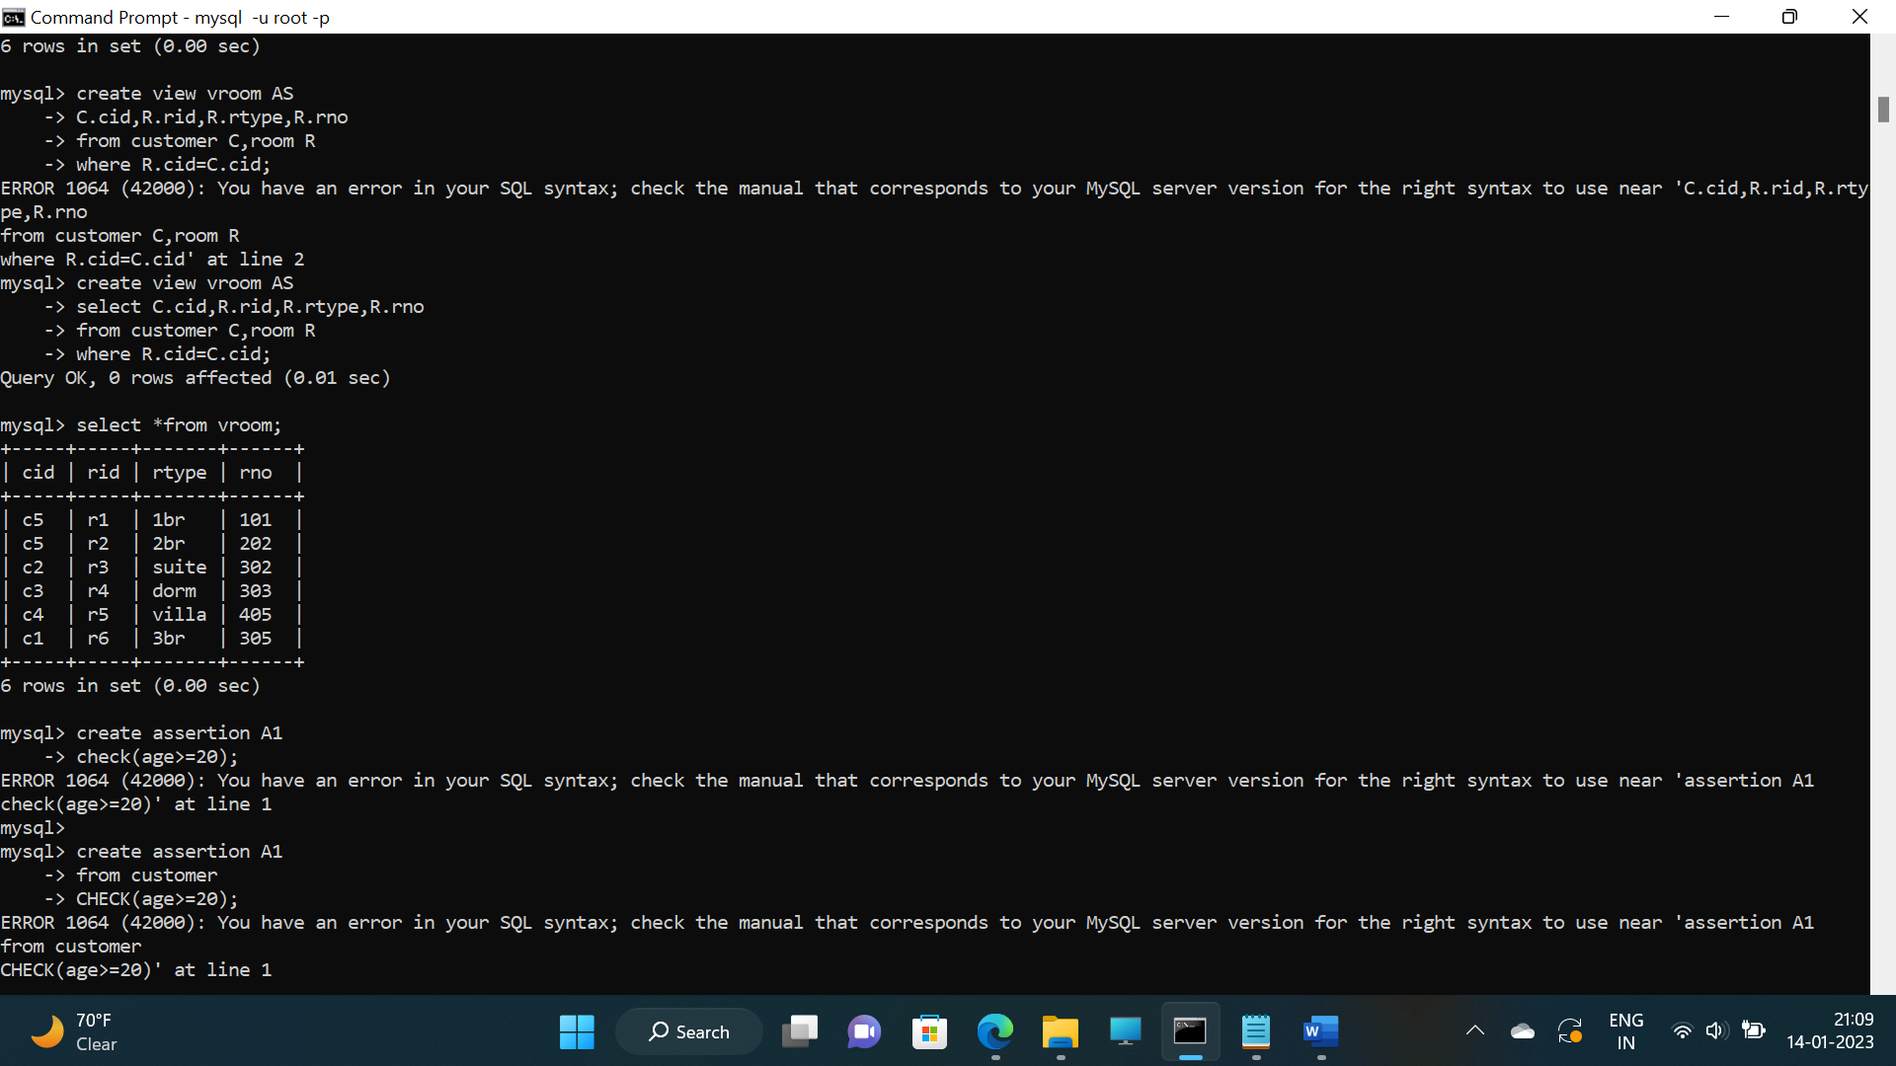

1. Delete employee id and show the changes in all the tables.

>delete from employee

where eid='e5';

